Github: https://github.com/hjschenck/nlp_project

ABSTRACT
Introduction: The restaurant industry is highly competitive and reviews strongly influence success. Restaurants need timely and detailed feedback for continuous improvement and innovation. The goal of the present study is to build a multi-label sentiment classifier for restaurant reviews that analyzes overall and aspect-based (food, service, ambiance, price, context) sentiment to provide timely and granular feedback for restaurants.
Methods: Using keyword spotting for aspect identification and data from the Yelp open database, we compared a TF-IDF + Logistic regression baseline model with a fine-tuned DistilBERT transformer model to predict sentiment for the 5 aspects and an overall review sentiment. VADER was used to generate proxy labels for sentiment classification for the entire Yelp database review set due to the large data scale. However, our approach was corroborated by using human-labeled star ratings to predict overall sentiment and training/testing both models using this data.
Results: 1.5 million reviews were included (80%/20% train/test split).The transformer-based model had superior precision, recall, weighted F1-score, accuracy and micro/macro averages across all 6 labels compared to the baseline logistic regression model. For the overall sentiment, the superior performance was corroborated using data with human-generated manual labels to complement experiments with VADER generated proxy labels.
Conclusions: A fine-tuned transformer (DistilBERT) model is highly effective for multi-aspect and overall sentiment classification for restaurant reviews, significantly outperforming a logistic regression model. This should prove useful for the provision of rapid granular and summary review analysis for restaurants for continuous improvement.

INTRODUCTION
Restaurant reviews generated from professional food critics as well as from everyday customers have become ubiquitous, being visible across many platforms and media sources. These reviews can be a rich source of information both to future patrons as well restaurants themselves and can strikingly influence consumer behavior and restaurant refinements.

The problem is to build a multi-label sentiment classifier that analyzes restaurant reviews and assigns sentiment scores not only to the overall review but also to specific aspects like service, ambiance, food, price, and context. This goes beyond simple positive/negative classification by providing a more granular understanding of customer opinions. The goal is to provide restaurant owners with a rapid classification of all restaurant reviews on a frequent basis in order to provide timely feedback as part of a continuous improvement program. This is an interesting problem as the restaurant business is highly competitive and reviews by food critics and restaurant reviewers can strikingly influence the future success of restaurants. Our classifier will also provide breakdown by critical categories as outlined above. Moreover, restaurants that are committed to receiving feedback and attempting to incorporate such feedback to facilitate continuous improvement are more likely to proceed. An appropriate classifier that is reliably constructed can provide near real-time feedback integrating data from disparate sources. Other interesting aspects:
- Granularity: Analyzing sentiment across multiple aspects provides deeper insights than a single overall score. This can help restaurants pinpoint specific areas for improvement.
- Contextual Understanding: Incorporating context (e.g., "for a quick lunch," "for a special occasion") can significantly enhance sentiment analysis accuracy.
- Practical Application: The results can be directly used by restaurants for customer feedback analysis, marketing, and operational adjustments.
- Natural Language Complexity: Restaurant reviews often contain nuanced language, sarcasm, and implicit opinions, making it a challenging and interesting NLP task.

BACKGROUND/RELATED WORK:

Our project builds upon prior research in aspect-based sentiment analysis (ABSA).
- Duan (2018): Aspect-based opinion mining with yelp restaurant reviews. This work focuses on identifying common topics using LDA and then extracting aspects and sentiments specifically for restaurants. It discusses preprocessing, aspect extraction, categorization, and sentiment analysis, providing a pipeline similar in goal to this project but potentially using different techniques (like LDA for topic modeling).
- Alamoudi and Alghamdi (2021): Sentiment classification and aspect-based sentiment analysis on yelp reviews using deep learning and word embeddings. This paper analyzes Yelp restaurant reviews using machine learning, deep learning (DL), and transfer learning models for binary and ternary sentiment classification. It proposes an unsupervised approach for aspect-level sentiment analysis (food, service, ambiance, price) based on semantic similarity using pre-trained embeddings like GloVe, achieving high accuracy with models like ALBERT.
- Peng (2020): Aspect based rating prediction for yelp customer review. This work predicts Yelp review ratings based on review text and other features. It creates dictionaries to identify <aspect-noun, sentiment word> pairs and uses these as features. The focus is rating prediction rather than just aspect sentiment classification, but the aspect identification step is relevant.
- Akhtar et al. (2024): Explainable Aspect-Based Sentiment Analysis Using Transformer Models. This article examines the performance of various transformer models on ABSA and utilizes explainability techniques (LIME, SHAP, Attention Weights, etc.) to understand their decision-making. While not specific to Yelp, it validates the use of transformers for ABSA, similar to this project's approach, and adds the dimension of explainability.
- Musa et al. (2024): HauBert: A transformer model for aspect-based sentiment analysis of hausa-language movie reviews. This paper presents HauBert, a fine-tuned mBERT model for ABSA on Hausa movie reviews. Although the domain (movies) and language (Hausa) differ, it demonstrates the successful application of fine-tuning transformer models (like BERT) for ABSA tasks, achieving high accuracy in aspect extraction and polarity classification, which aligns with the methodology used in this project with DistilBERT.
- Gan Q et al. (2017): A text mining and multidimensional sentiment analysis of online restaurant reviews. The authors attempt to delineate the structure of online restaurant reviews and investigate the influence of review attributes and sentiments on restaurant star ratings. The authors utilized the Yelp Dataset Challenge consisting of restaurants in Phoenix with 7,508 restaurants and 268,442 reviews identified for inclusion. The authors used a naive Bayes algorithm. The authors demonstrate that five attributes, food, service, ambience, price and context, explain the differences in star ratings with the greatest influence attributed to food, service and context. The inclusion of context as an attribute was an incremental contribution of this work.
Comparison: This project aligns with existing research by employing aspect-based sentiment analysis on Yelp data for classification but also incrementally builds on this foundation. We included a fine-tuned DistilBERT model and compared this to a logistic regression baseline model. The present study also can be distinguished from prior work by focusing on a recent and very large dataset (the entire Yelp Open Dataset for 01/01/2019-12/31/2024) across a broad geographic area (> 1.5 million reviews) and implementing a multi-output classification approach directly with the transformer model (as opposed to other papers using Naive Bayes, for example), rather than separate models per aspect or solely relying on keyword spotting/lexicons for the final classification step. We also used VADER to create proxy labels for sentiment categorization and corroborated this by using human-labeled reviews for overall sentiment-analysis combining datasets using both methods for validation.
APPROACH

Method: We approached our problem using the following methods:
- Aspect Definition & Keyword Spotting:
  - Five primary aspects were defined: 'food', 'service', 'ambiance', 'price', and 'context'.
  - Keyword lists were created for each aspect.
  - Sentences within each review were classified into the aspect with the highest keyword count, following the methodology described in related literature. Sentences without keywords were labeled 'other'.
- Sentiment Analysis (Initial):
  - NLTK's VADER (Valence Aware Dictionary and sEntiment Reasoner) was used to calculate a compound sentiment score (-1 to +1) for each sentence.
  - Weighted sentiment scores for each aspect per review were calculated based on the proportion of sentences assigned to that aspect and their summed sentiment scores, aiming to replicate a methodology described in related work.
- Sentiment Analysis - Overall Sentiment (Part 2)
  - We used the human-labeled stars rating for the entire dataset
  - Both investigators selected a random sample of 200 reviews to validate the human-labeled star rating based upon the written review content
- Text Preprocessing:
  - Standard text preprocessing techniques were applied to the review text: lowercasing, removing URLs and punctuation, tokenization using NLTK, stop word removal (NLTK English stopwords), and lemmatization using WordNetLemmatizer.
- Target Variable Creation (Sentiment Discretization):
  - The calculated continuous sentiment scores per aspect were discretized into three categories (negative, neutral, positive) using fixed thresholds (negative < 0.05, neutral (>-0.05 and <0.05, positive > 0.05). These discrete labels (0, 1, 2) served as the target variables for the classification models.
- Modeling:
  - Baseline Model:
    - Feature Extraction: TF-IDF (Term Frequency-Inverse Document Frequency) vectorization was applied to the preprocessed text, limited to the top 5000 features.
    - Classifier: A Logistic Regression model was used as the base estimator, wrapped in Scikit-learn's MultiOutputClassifier to handle the prediction for all five aspects simultaneously.
  - Advanced Model (Transformer):
    - Model: A pre-trained DistilBERT model (distilbert-base-uncased) from the Hugging Face Transformers library was fine-tuned for the multi-aspect classification task.
    - Architecture Modification: The standard classifier head was replaced with a linear layer outputting scores for each class within each aspect (total output size: num_aspects * num_classes_per_aspect, e.g., 5*3=15).
    - Training: The model was trained using PyTorch, with the AdamW optimizer, a linear learning rate scheduler, and CrossEntropyLoss (calculated by reshaping logits and labels appropriately for the multi-output task).
- Evaluation:
  - Both models were evaluated on a held-out test set (20% of the data).
  - Metrics included precision, recall, F1-score, and accuracy, calculated per aspect.
  - Overall performance was assessed using micro and macro averages across all aspects.
  - Scikit-learn and PyTorch libraries were used for implementation and evaluation.
- Validation of VADER proxy labeled sentiment data with human labeled data
  - To corroborate the results of both models trained and tested on VADER-labeled sentiment data, we performed training and testing of both models (as outlined above) on human-labeled overall sentiment data
EXPERIMENT
We conducted the training and testing of both the DistilBERT and logistic regression models as outlined above.

Data: We selected the Yelp Open Dataset of businesses and reviews (https://business.yelp.com/data/resources/open-dataset/), specifically the yelp_academic_dataset_review.json and yelp_academic_dataset_business.json files. We downloaded the datasets and chose initially to focus on the New Orleans Greater Metropolitan Area including target cities of New Orleans, Metairie, Kenner, Gretna, Harahan, Westwego, Chalmette and Slidell. We then searched for businesses in these cities and specifically selected those businesses related to “restaurant/food”. We created a list of target business ID numbers and then searched from 01/01/2019 to 12/31/2024 pulling all reviews of these target businesses. This resulted in 4099 unique restaurant business IDs. We then processed the data collecting the review ID, text, stars and date of review. The dataset for analysis comprised 20,377 reviews. We then cleaned and preprocessed the text data. We calculated overall sentiment scores and aspect sentiment scores (food sentiment, service sentiment, ambiance sentiment, price sentiment and context sentiment).

Based upon preliminary experiments, the New Orleans only data appeared to be too limited especially for certain categories including ambiance, price and context. We subsequently expanded this to include the entire Yelp database over the same time period with 64,629 unique businesses and 1,525,330 reviews. This expanded data set serves as the basis for our the following experiments and analysis.

Results:
The training set size comprised 1,220,250 reviews and the test set comprised 405,063 reviews.

The training of the DistilBERT model required significant computing resources and time. The fine-tuned Distilbert model had a modified classifier head for multi-output prediction (6 labels*3 classes=18 outputs). We trained in 3 Epochs with batches of 100 using an A100 GPU available through Google Colab ProPlus. Each epoch took >190 min to train or about 10 hours in total (~3 times longer on a lesser GPU). Please refer to our Colab printed data for further details.

For the logistic regression model, the following results were obtained:

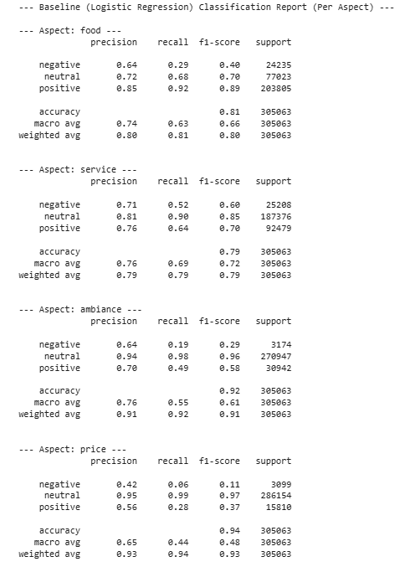
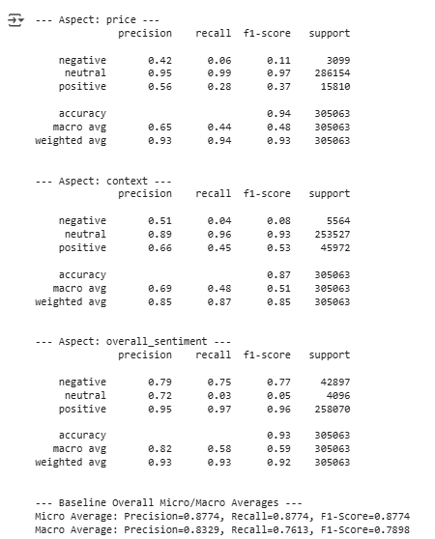

For the DistilBERT model, the following results were obtained:
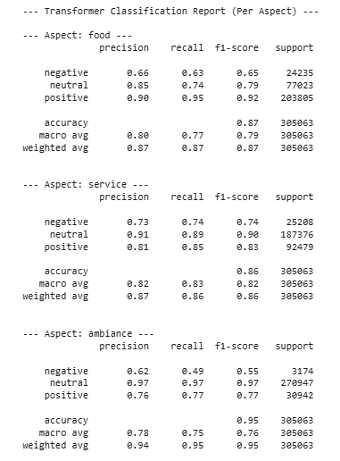
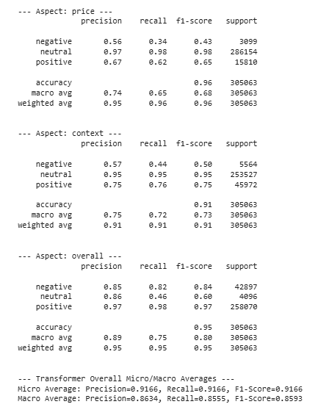

As can be seen, the DistilBERT model appears to have consistently outperformed the logistic regression model across all aspects and outcome measures.
The F1 weighted average is a robust metric for evaluating sentiment classification models, especially when dealing with imbalanced datasets, as it combines the precision-recall balance of the F1 score with a weighting scheme based on class prevalence. F1 weighted average is a robust metric for evaluating sentiment classification models, especially when dealing with imbalanced datasets, as it combines the precision-recall balance of the F1 score with a weighting scheme based on class prevalence. The following table compares the Weighted F1-Score on the test set between models:

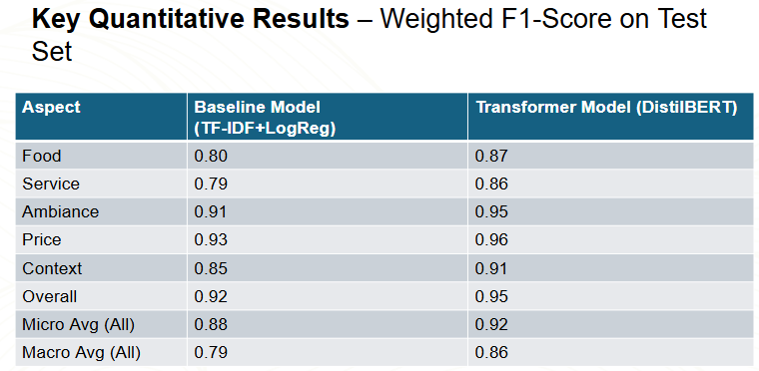

Vader for the use of proxy labels in a large data set:
One criticism of our approach is that we used VADER to initially create proxy sentiment labels. This discussion provides our rationale for doing so and some considerations for overcoming associated limitations. One could ask why not simply use VADER for sentiment classification as opposed to a DistilBERT model trained on VADER labels. The following is our rationale:There are advantages of our transformer model trained on VADER Labels vs. VADER Alone:
- Contextual Understanding & Nuance: VADER's Approach: NLTK-VADER is primarily lexicon-based and rule-based. It analyzes sentiment based on predefined scores for words and applies simple rules for intensifiers, negation, etc. While effective for many cases, it can struggle with complex sentence structures, sarcasm, or context where the sentiment isn't explicitly stated by keywords. Transformer's Advantage: Transformer models like DistilBERT are designed to understand context. By processing the entire review text, they learn relationships between words and phrases. Even when trained on labels generated by VADER, the transformer can learn patterns associated with VADER's positive/negative/neutral classifications that go beyond VADER's explicit rules. It might capture nuances in how sentiment is expressed for different aspects (food, service, etc.) that VADER's general lexicon wouldn't differentiate.
- Generalization: VADER's Limitation: VADER's performance is tied to its fixed lexicon and rules. It might not handle novel phrasings or slang as effectively if they aren't in its dictionary. Transformer's Advantage: By training on a massive dataset (even one labeled by VADER), the transformer learns a more generalized representation of language associated with different sentiment scores and aspects. It learns from the distribution of text features linked to VADER scores across 1.5 million reviews. This can lead to better performance on unseen reviews that might use slightly different language than what VADER's rules explicitly cover. The model essentially learns a "smoothed" version of VADER's logic, potentially mitigating some of VADER's inconsistencies.
- Potential Efficiency at Inference: VADER's Process: The VADER implementation involves several steps per review: sentence tokenization, keyword searching for aspect classification, running VADER's sentiment analysis on relevant sentences, and aggregating scores. Transformer's Advantage: Once trained, the DistilBERT model requires only a single forward pass through its network to predict sentiment for all aspects simultaneously. Depending on hardware and optimization, this could be faster for processing new reviews compared to the multi-step VADER pipeline, especially at scale.
- Capturing Aspect-Specific Sentiment: VADER's General Nature: VADER applies a general sentiment lexicon. Transformer's Advantage: Your transformer was trained specifically for the multi-aspect task. It learns to map input text features to sentiment scores for each specific aspect. While the initial labels came from VADER applied to keyword-filtered sentences, the model might learn subtle linguistic cues that are more indicative of sentiment towards 'food' compared to 'service', for instance.

The following were key rationale for our approach:
- Scalability: Manually labeling over 1.5 million reviews for five different aspects plus overall sentiment is practically infeasible. Using VADER to generate proxy labels was a necessary and pragmatic choice to handle this scale.
- Leveraging Strengths: We combined VADER's ability to provide large-scale (if imperfect) labels with the transformer's power to learn complex, contextual patterns from that large dataset. This is a common technique when human-labeled data is scarce.
- Corroboration: As we discussed, in a follow-up experiment we trained both models on human-labeled star ratings to predict overall sentiment, which serves as crucial corroboration. By showing that similar models (TF-IDF+LogReg and DistilBERT) achieve good performance (e.g., ~90-91% accuracy for overall sentiment prediction based on stars ) on human-verified labels, we demonstrate the fundamental soundness of our modeling approach. It suggests the models can effectively learn sentiment from review text, lending credibility to their ability to learn from the VADER-generated aspect labels as well.

Validation experiment using human-labeled sentiment reviews for overall sentiment analysis:
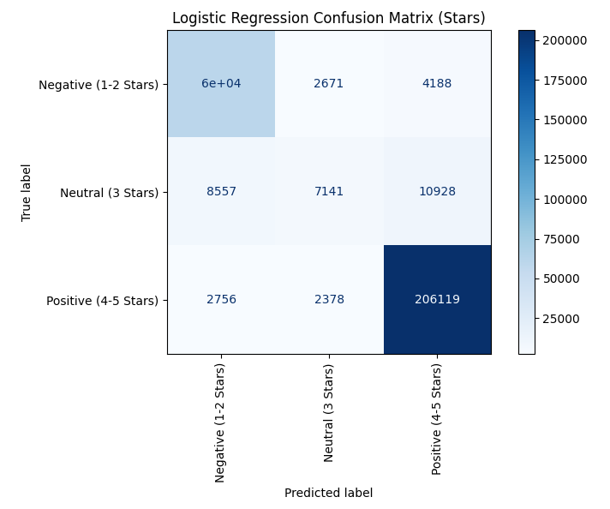
To provide validation to our approach above, we retrained and then retested both the DistilBERT model and logistic regression model based upon data from human-labeled reviews in the same 80/20 train/test split.
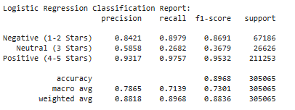

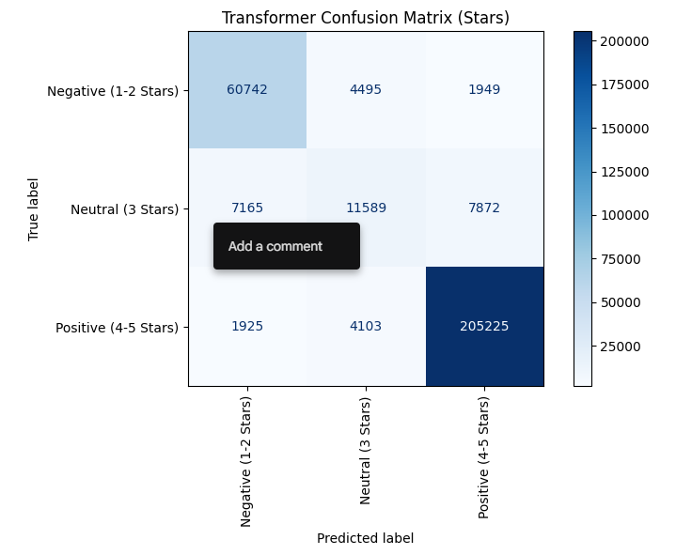
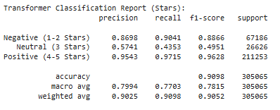

As for the models trained on the VADER proxy-labeled data, the DistilBERT model consistently outperformed the baseline logistic regression model which lends credence to our initial approach selected.

Comparison: The fine-tuned DistilBERT model consistently outperformed the TF-IDF + Logistic Regression baseline across nearly all aspects, demonstrating significantly higher F1-scores and accuracy, particularly in overall micro and macro averages. This highlights the effectiveness of transformer models in capturing complex patterns and nuances in the review text for this task. Example predictions show the model assigning sentiment labels ('positive', 'neutral', 'negative') to each aspect for given review texts.
Here is the initial input prompt:
Examples using the initial sentiment classifier:
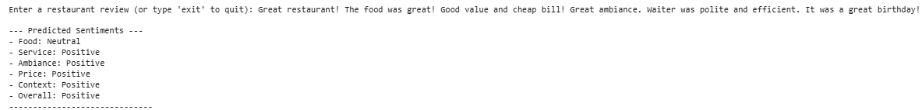
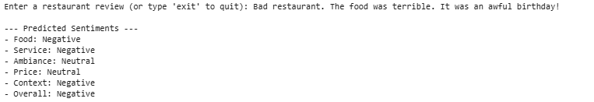
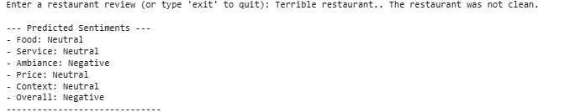
For some of the aspects with less examples, the outputs can be variable and depend very much on the specific words inputted. For example, this is evident with context as shown in the example below. “It was a bad birthday” is not interpreted as negative context, but “It was a terrible birthday experience” is interpreted as a negative context.
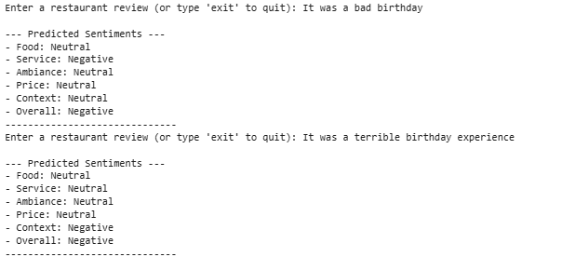
Examples using or human-labeled overall sentiment classifier:
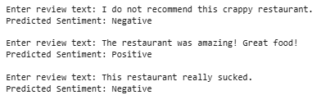
The overall sentiment classifier appears to work well. We did not detect systemic biases. It did make some mistakes. For example, when “bad restaurant” is typed, it recognizes this as a negative review. However, when “bad restaurant” is combined with “I would not come back” it gives a positive review and does not appear to readily recognize the negation in would NOT come back and thinks it is “would come back”.
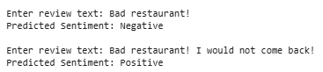
Taken collectively, errors appear where there were less instances encountered during the training such as price, ambiance and context. The wording does appear to matter. Some of the errors also map back to our list of key words and use of VADER for sentiment classification. We were able to achieve better objective outcome scores through expansion and refinement of key words defining the sentiment classes.
Division of Labor: The labor was divided equally. Aaron and Jacob both conceived the program components and design, jointly developed and edited the code. Aaron conducted the initial literature review and Jacob added additional papers and input. Jacob conducted the model refinement based upon testing and training data with Aaron offering input after additional testing. The report writing was conducted collaboratively by both Aaron and Jacob.

CONCLUSION
Fine-tuned transformer models, such as DistilBERT employed in the present work, are highly effective for multi-aspect and overall sentiment classification as applied to restaurant reviews. The DistilBERT model appeared to significantly outperform traditional methods like logistic regression. Additionally, granular and simultaneous overall analysis is feasible and is likely of significant value to restaurants and consumers providing accurate and timely feedback.

Future ideas include:
  - Refine aspect keyword lists
  - Add more training data, especially for weaker categories (e.g. ambiance, price, context) including both human-labeled and VADER-labeled data with detailed comparisons for each sentiment
  - Hyperparameter tuning for the transformer model
  - Manual tuning of sentiment score cutoffs
  - Possibly explore explainability techniques (LIME, SHAP) to understand model decisions

REFERENCES
- Akhtar, Z., Ahmad, T., Khan, M. A., & Ul Abidin, S. Z. (2024). Explainable Aspect-Based Sentiment Analysis Using Transformer Models. Applied Sciences, 8(11), 141. https://www.mdpi.com/2504-2289/8/11/141
- Al-Twairesh, N., & Al-Khalifa, H. (2021). Sentiment classification and aspect-based sentiment analysis on yelp reviews using deep learning and word embeddings. Journal of Decision Systems, 30(2-3), 226-252. https://www.tandfonline.com/doi/abs/10.1080/12460125.2020.1864106
- Duan, T. (2018). Aspect-based Opinion Mining with Yelp Restaurant Reviews. Duke University Statistical Science Theses. https://dukestatsci.github.io/thesis-sp18-duan-sentiment/
- Gan, Q., Ferns, B.H., Yu, Y., Jin, L (2016). A text mining and multidimensional sentiment analysis of online restaurant reviews. Journal of Quality Assurance in Hospitality and Tourism.https://www.tandfonline.com/doi/abs/10.1080/1528008X.2016.1250243?casa_token=3343pqRoCCwAAAAA:nULDsc5QgFROIP2shCOffBtXiwK_DoOktl2cm0OvD5CdNiU9nCmnH_mOKjlzP-yrIPv5Cfo4SSoumw
- Musa, A., Adam, F. M., Ibrahim, U., & Zandam, A. Y. (2024). HauBert: A transformer Model for Aspect-based Sentiment Analysis of Hausa-Language movie reviews. Proceedings of the 5th International Electronic Conference on Applied Sciences. https://sciforum.net/paper/view/20914
- Peng, G. (2020). Aspect Based Rating Prediction For Yelp Customer Review. Master's Paper, University of North Carolina at Chapel Hill. https://cdr.lib.unc.edu/downloads/4f16c8090?locale=en

